Working with Big Data using Multithreading

David Graves
Colorado State University Global
CSC507
Dr. Joseph Issa
August 27, 2025

Working with Big Data
Working with Big Data presents unique challenges that require specific approaches to efficiently process and manipulate. Today we capture many different types of data in different formats from nearly every corner of our lives. This can be helpful when translated efficiently into well-structured output that can be actionable and conversely can be extremely frustrating if the correct approach to processing said data isn’t well thought through. I’ll use the remainder of this paper to apply concepts recently learned to examine and explore the most efficient ways to process massive data sets containing 1 billion rows of data. I’ll use three different approaches including as-is line-by-line processing, multithreading and breaking the initial files into smaller sets of data, to take both massive data sets of random numbers and add the values of the rows together to produce one output file that represents the sum of both together.
Processing Big Data with Different Approaches
Prior to writing and executing the first algorithm, I created both the input files that would be used for processing all the different algorithmic approaches shown in Image 1 below.
Image 1 (hugefile*.txt)
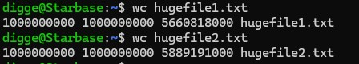
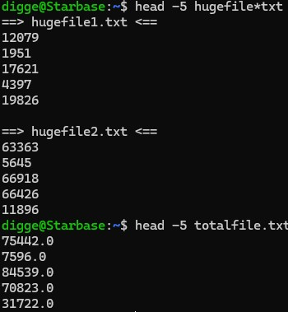
Armed with the input files I created and executed the first approach, as-is, which produced the output file as shown in Image 2 below. This algorithm executed the task correctly and did so in 1,779 seconds (29 minutes 39 seconds).
Image 2 (As-Is)
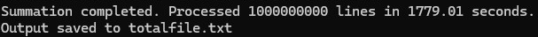
For this first approach I used the ‘open ()’ function for both input files and iterated over a loop to process line by line to output the sum from both input pairs into one file ‘totalfile.txt’. I chose this approach, which worked decently well, because “this function is best for when you have a static number of known file streams and straightforward line-by-line processing.” (Collins, 2024) As mentioned this was able to handle processing the data set, but it’s helpful to see what other approaches might make this more efficient. The next approach I took was multithreading in the hopes that it might be more efficient since, “on a multiprocessor system, multiple threads from the same process may be able to execute simultaneously.” (Stallings, n.d.) I wrote the script to leverage all 4 cores of my processor by breaking the work into threads. The program executed the task correctly as shown in Image 3 below, however it wasn’t any faster in completing this in 1948 seconds (32 minutes 28 seconds) than the ‘as-is’ approach did in 1,779 seconds (29 minutes 39 seconds).
Image 3 (Multithread)
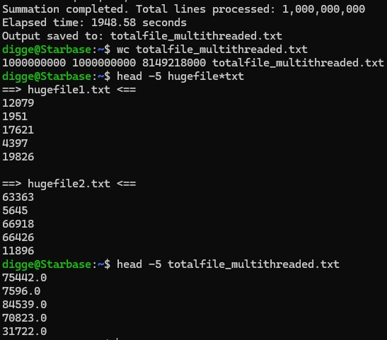
This result was somewhat surprising in that it was no better than the first attempt. My best guess as to why this was not more efficient is because the task I’ve asked of the program is CPU bound and, “the Python GIL being the bottleneck preventing threads from running completely concurrently” (editor, n.d) limited its effectiveness. By using the Python programming language to write the script, the serialized ‘as-is’ script outperformed the threaded one. The last attempt to create a more efficient script was to break up both input files into 10 files each and run the process on those subsets in parallel. Like the first two scripts, I used Python to write this one and it properly executed the summing and consolidation of output into one file as shown below in Image 4. This version was the slowest of the three programs clocking in at 2146 seconds (35 minutes 46 seconds).
Image 4 (10 split)
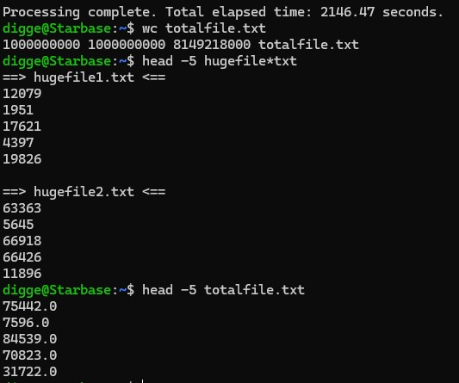
This result was also somewhat surprising since intuitively it seems like by breaking the problem into smaller parts it might be faster. That said, I believe the main reason for slowness here could be due to the overhead associated with the initial file splitting and time associated with reassembly as well as the time it took to create new interim file structures. I did some tinkering with this one to no avail but think that with additional work and greater expertise with Python this one could be better optimized.
Reflection
I anticipated that I would find a more efficient route to processing the two massive input files as I progressed, yet I found that with my machine the straightforward ‘as-is’ approach seemed to produce the best results, not to mention the code was easier to manage. In reviewing additional research, I found that other’s have found that, “the efficient approach (cases like this) reads each row from the input file, processes it, and writes the processed row directly to the output file.” (Ainomic, 2023) An additional factor for this may be the devil in the detail of the two subsequent code attempts that I may not have been able to optimize as a ‘still-learning’ Python coder. Either way, I’m happy that I was able to produce the correct result of tackling a processing problem involving massive data sets using three different approaches. This should serve me well as I continue to learn and use tools with real-life examples.

References
Ainomic Technology (2023, Dec 11). A Memory-Efficient Pythonic approach to process massive
CSV files.
A Memory-Efficient Pythonic approach to process massive CSV files | by Ainomic Technology | Medium
Collins, Emily Rosemary (2024, March 11). Blog.finxter.com. 5 Best Ways to Iterate Over Lines
From Multiple Input Streams in Python.
5 Best Ways to Iterate Over Lines from Multiple Input Streams in Python – Be on the Right Side of Change
Editor (n.d). phicygni.com. Why is multi-threaded Python so slow?
Why is multi-threaded Python so slow? | by Emile Rossouw | Phi Cygni
Stallings, W. (n.d.). Operating Systems: Internals and Design Principles, 9/e.
Retrieved from https://platform.virdocs.com/read/2228445/46/#/4/2[P7001013869000000000000000001544]/12[P7001013869000000000000000001551]/34[P700101386900000000000000000B374],/1:0,/1:0

